**74181 4-Bit ALU/Function Generator**

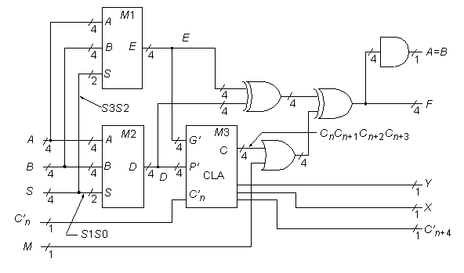

**Statistics:** 14 inputs; 8 outputs; 61 gates; [gate-level schematic](http://web.eecs.umich.edu/%7Ejhayes/iscas.restore/74181gates.html)

**Function:** The 74181 can be modeled as above. Recognizing the logic that makes up a CLA block�in this case, the circled elements in the [gate-level schematic](http://web.eecs.umich.edu/%7Ejhayes/iscas.restore/74181gates.html)�is the key step in unraveling the secrets of the 74181. The four boxed circuits in the [gate-level schematic](http://web.eecs.umich.edu/%7Ejhayes/iscas.restore/74181gates.html) are represented above by the single module [M1](http://web.eecs.umich.edu/%7Ejhayes/iscas.restore/74181m1.html) with 4-bit I/O buses. The second quadruplicated circuit in the 74181 leads to the high-level module [M2](http://web.eecs.umich.edu/%7Ejhayes/iscas.restore/74181m2.html). The various XOR gates are also grouped into 4-bit word gates as indicated above. Further analysis shows that the 74181�s original designers cleverly constructed the M1 and M2 logic so that with input line *M* = 1, each setting of the *S* (function select) bus produces one of the 16 possible Boolean functions of the form *F*(*A,B*).

**Note:** The M line above has been logically moved from within the CLA block M3, to after the block. This was done to make module M3 a standard CLA block. The change preserves the function, but does make subtle differences when analyzing, for example, path delays in the two circuits.

**Models:**

* [74181 ISCAS-85 netlist](http://web.eecs.umich.edu/%7Ejhayes/iscas.restore/74181.isc)
* [74181 Verilog structural model](http://web.eecs.umich.edu/%7Ejhayes/iscas.restore/74181.v)
* [74181 behavioral model](http://web.eecs.umich.edu/%7Ejhayes/iscas.restore/74181b.v)
* [74181 complete gate-level tests](http://web.eecs.umich.edu/%7Ejhayes/iscas.restore/74181.tests)

**74181 Gate-Level Schematic**

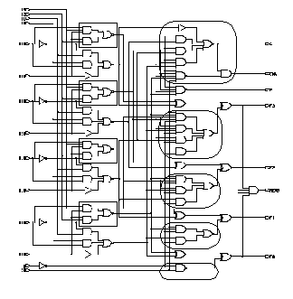

**74181 Module M1**

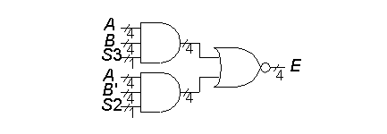

**74181 Module M2**

